Practical 6
COS214
TIVIDY is a generic case-processing workflow management system
Group Members:
Lindokuhle Skosana - u24891968
Kristy Heesen - u24702341
LM Kabongo -25030338
Joshua Peter – 23626527
Musa Msibi - 25098022

TASK 1
Research:
IBM defines a workflow as [1] a system for managing repetitive processes and tasks which occur in a particular order. They are the mechanism by which people and enterprises accomplish their work. Simply, a workflow is a repeatable sequence of steps that moves a process from start to finish. Workflow management systems are [2] systems designed to assist groups of people in carrying out work processes, and contain organizational knowledge of where work flows in the default case.
A workflow definition is [3] a template or blueprint for a process and a running workflow instance is [4] a single active execution of the template. Activities and work items are typically represented as [5] distinct nodes, data structures or objects that define and track how work moves in the system. Work items are generally assigned on a hierarchical basis where a “principal” (usually a customer or a boss) assigns a work item which are received can be passed down the hierarchy [6]. Approvals, rejections and escalations are usually based on human interaction, algorithms, timers or escalation events [7].
In a workflow management system participants, roles and responsibilities are typically represented by assigning people or systems to roles and then assigning those roles to workflow tasks [8]. Dependencies restrict activities until preceding work has been completed. Events act as triggers that mark when a workflow activity should begin or continue and failures are handled using defined methods such as error handling, retries or escalation. Workflows typically interact with external systems by exchanging data, triggering events and coordinating communication.
Workflow history and audit information is recorded through automatic logging that ensure that every step of a process is captured and traceable across a process [9]. Running workflows are monitored through real time data collection and tracking [10]. A workflow engine can be made to be reusable across different processes by being designed in such a way that the modelling and monitoring of tools, ways of interacting with resources and ways of different activities or work items interacting with each other all operate under the general case [11]. Simply put, it needs to separate the execution mechanics from specific business knowledge.
The workflow definition is static and therefore holds information about the structure of the workflow such as conditions, assigned roles and rules. A running instance holds information about one specific workflow such as its unique ID, current state and completed and pending tasks [3]. Real workflows model nested activities and sub-processes using hierarchies and rules where the parents execution is paused until the child completes their task [6]. In a workflow system, business decisions are usually configurable (able to be changed to meet specific requirements) such as routing decisions, approval rules, time limits, etc. Finally, changes can be made to workflow definitions while work is in progress by “workflow versioning” [12], this involves creating a branch from the public version, and publishing the new branch and storing the outdated branch in a version history.
The research indicates that TIVIDY should provide a generic mechanism for defining and executing workflows rather than implementing one fixed problem-solving process. It’s core concepts should include WorkItems, workflow definitions and instances, activities, participants roles, routing, states, events escalation, history and monitoring. These capabilities can then be used in different scenarios such as complaints, IT problems and work-task management, while the underlying system remains the same.
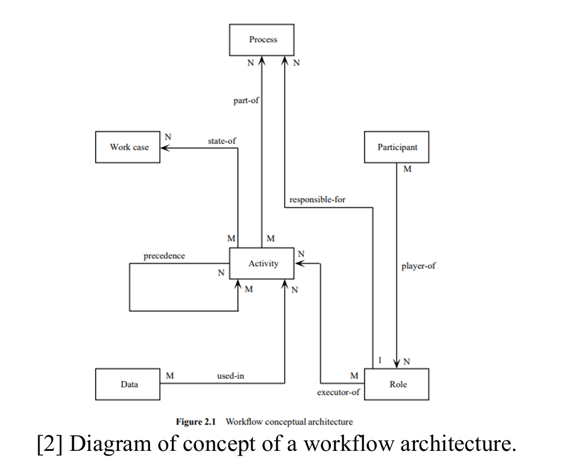
References:
- IBM (2026a) What is a workflow? IBM Think. Available at: https://www.ibm.com/think/topics/workflow (Accessed: 2 October 2026).
- Ellis, C.A. (1999) ‘Workflow Technology’, in Beaudouin-Lafon, M. (ed.) Computer Supported Cooperative Work. Chichester: John Wiley & Sons. Available at: https://www.lri.fr/~mbl/cgi-bin/getpdf.cgi?Trends-CSCW/chap2.pdf (Accessed: 2 October 2026).
- IBM (2026b) Workflow definitions and workflow instances. IBM OpenPages Documentation. Available at: https://www.ibm.com/docs/en/openpages/9.2.x?topic=fundamentals-workflow definitions-workflow-instances (Accessed: 2 October 2026).
- TMS Software (2025) Basic concepts. TMS Workflow Studio Documentation. Available at: https://doc.tmssoftware.com/biz/workflow/guide/basic.html#workflow-instance (Accessed: 2 October 2026).
- IBM (2026c) Workflow elements. IBM Documentation. Available at: https://www.ibm.com/docs/en/sig-and-i/11.0.2?topic=planning-workflow-elements (Accessed: 2 October 2026).
- Aalst, W.M.P. van der and Hee, K.M. van (2001) Workflow Management: Models, Methods, and Systems. Eindhoven: Eindhoven University of Technology. Available at: https://pure.tue.nl/ws/files/2456322/543561.pdf (Accessed: 2 October 2026) [page 21 – “Allocating and accepting work”].
- Camunda (2026) User tasks. Camunda 8 Documentation. Available at: https://docs.camunda.io/docs/components/modeler/bpmn/user-tasks/ (Accessed: 2 October 2026).
- IBM (2026d) Workflow processes and user responsibilities. IBM Documentation. Available at: https://www.ibm.com/docs/en/max-it/cd.0.0_cd?topic=components-workflow-processes user-responsibilities (Accessed: 2 October 2026).
- Hyperbots (2026) Workflow history. Available at: https://www.hyperbots.com/glossary/workflow-history (Accessed: 2 October 2026).
- SearchInform (2026) Workflow management: Monitoring. Available at: https://searchinform.com/articles/cybersecurity/measures/security-monitoring/workflow management/monitoring/ (Accessed: 2 October 2026).
- Ferreira, D. (2004) Developing Workflow Management Systems. Available at: https://web.ist.utl.pt/diogo.ferreira/papers/ferreira04developing.pdf (Accessed: 2 October 2026).
- JetAdmin (2026) Workflow versioning. Available at: https://www.jetadmin.io/ (IBM, 2026)blog/workflow-versioning/amp/ (Accessed: 2 October 2026).

TASK 2
Initial Scope of TIVIDY:
TIVIDY is a generic case-processing workflow management system. It manages submitted cases through review, assignment, processing, decision-making, escalation and closure.
The system provides reusable workflow features that allow it to be used by different organisations for a variety of problems.
The main responsibility of TIVIDY is to manage the movement of work. This is achieved through a structured process. It must be able to create and run workflow instances, manage work items, assign work to participants, track the state of work, apply routing and escalation rules, record workflow history, as well as determine when a workflow has been successfully completed.
Workflow Definition vs Running Instance:
A workflow definition describes the operation of a type of process. It contains the steps, rules, roles, dependencies, as well as possible routes through the process.
A workflow instance represents a running execution of that definition. Each instance has its own unique participants, data, current state, progress and history.
The same workflow definition can, as a result, be used to create many independent workflow instances. Changes to one instance do not affect the other instances.
System Boundaries of the workflow manager:
TIVIDY is responsible for managing the workflow, not performing the real-world work itself.
This includes:
- Creating workflow definitions and instances
- Creating and managing work items
- Assigning work
- Tracking states
- Checking dependencies
- Routing work
- Escalating work
- Reacting to events
- Recording workflow history
- Determining when the workflow is complete

TIVIDY does not perform the actual work assigned to a participant. TIVIDY may also communicate with external systems.
Parts of the System That May Vary:
Different organisations may manage and operate their processes differently. Some parts of TIVIDY should, as a result, be able to change without requiring the workflow system to be redesigned.

These may include:
- How work is assigned
- How escalation is handled
- How approvals are handled
- How the next work item is selected
- How workflow definitions are constructed
- How events are handled
For example, one organisation may assign work according to a participant's role, while another organisation may assign work according to current workload.
Selected Scenario - University Student Complaint Management:
Organisation/Environment:
The chosen scenario is for a university.
The university receives complaints from students. This may relate to matters regarding academic issues, finance, administration or student services.
TIVIDY is used to manage these complaints from submission until resolution.
Process Being Managed:
A student submits a complaint. The complaint is then reviewed by an administrator, classified and routed to the correct department accordingly.
A staff member investigates the complaint and attempts to resolve it. If the complaint cannot be resolved at that level, it may be escalated to a person with greater responsibility who can resolve it accordingly.
Once a decision has been made, the student may accept the outcome or appeal the decision. If the student accepts the outcome, the complaint is resolved. If the student appeals, the appeal is reviewed. If the appeal is upheld, the complaint returns for further processing. If the appeal is denied, the complaint is closed.
The workflow eventually ends when the complaint has been resolved or closed. A complaint is closed if the student retracts it or if a final appeal is denied.
Participants and Roles:
Student: Submits the complaint and receives the outcome.
Administrator: Reviews the complaint, identifies its type and routes it to the appropriate department.
Staff Member or Lecturer: Investigates the complaint and attempts to resolve it.
Department Head: Handles complaints that cannot be resolved at the first level or that require higher-level approval.
Faculty Representative: May handle complaints that require further escalation.

Major Pieces of Work:
The workflow contains the following main work items:
- Submit complaint
- Review complaint
- Identify complaint type
- Assign complaint
- Investigate complaint
- Make decision
- Resolve complaint
- Escalate complaint
- Review appeal
- Close complaint
Important Decisions and Routing Points:
Important decisions include:
- What type of complaint is this?
- Which department should receive it?
- Can the assigned staff member resolve it?
- Should the complaint be escalated?
- Does the student accept the decision?
- Should an appeal be created?
The result of these decisions determines which work item becomes available next and how the workflow continues.
Approvals and Dependencies:
Some work items depend on earlier work being completed.
For example:
- The complaint must be submitted before it can be reviewed.
- The complaint must be reviewed before it can be assigned.
- The complaint must be assigned before investigation can begin.
Possible Failures or Exceptions:
Possible failures or exceptions include:
- The student provides insufficient information.
- The complaint is assigned to the wrong department.
- The complaint cannot be resolved at the current level.
- An email notification fails.
- The student withdraws the complaint.
- The student appeals the decision.
TIVIDY must allow the workflow to respond appropriately when these situations occur.
External Systems:
TIVIDY may interact with an external email notification system.
For example, when a complaint is submitted, the student then receives a confirmation email. When the complaint is assigned, the staff member is then notified. If the complaint is escalated, the Department Head is notified. When the complaint is resolved, the student is informed.

Expected Outcome:
The expected outcome is that the complaint reaches a final state.
Possible final outcomes include:
- Resolved
- Closed after the student retracts the complaint
- Closed after a final appeal is denied
The workflow should also keep a history of the actions and state changes that occurred during the process.

TASK 3

Activity Diagram 1
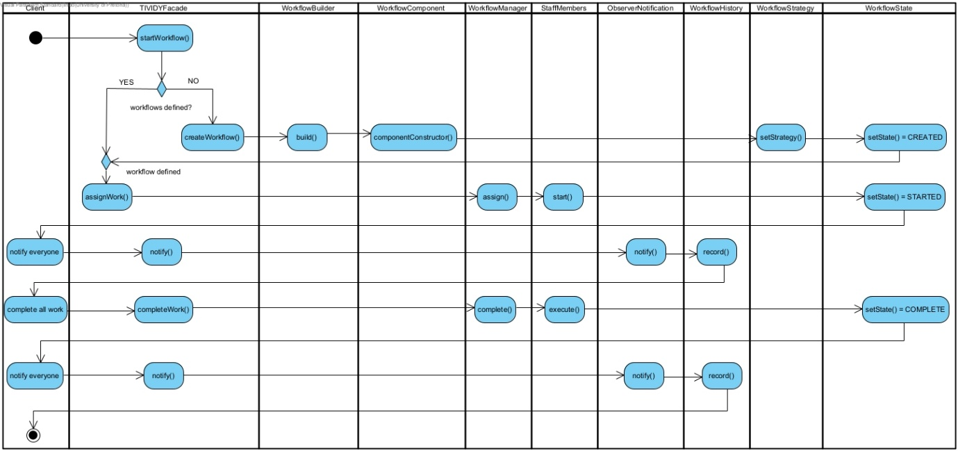

Activity Diagram 2
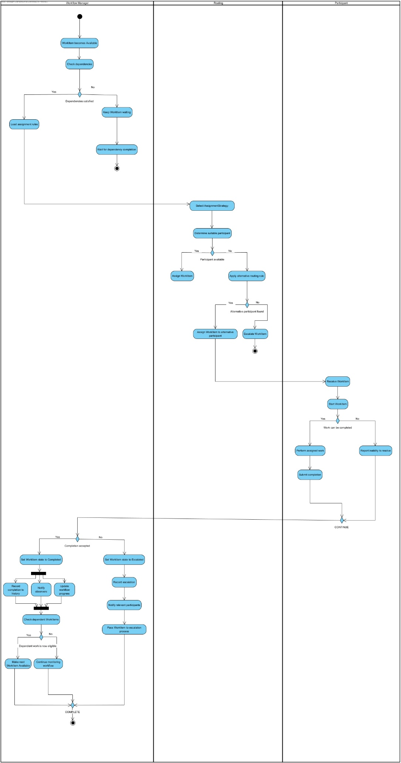
Activity Diagram 3
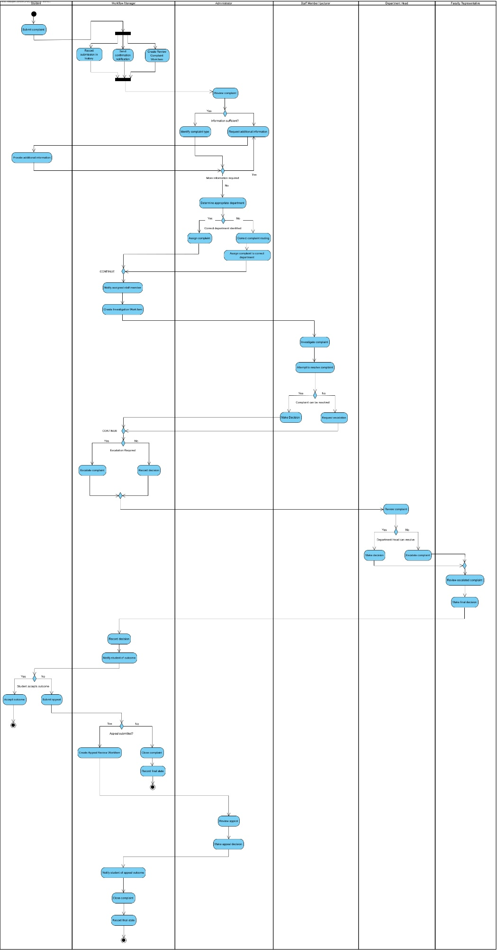

TASK 4
Design Patterns for TIVIDY:
1. Observer Pattern
Design Problem
Different parts of TIVIDY may need to react when something happens during a workflow.
When a work item is completed, the system may need to:
- Notify a participant
- Update workflow progress
- Record the action in history
- Check whether another work item can begin
Possible Classes
Subject:
WorkflowInstance
WorkItem

Observers:
NotificationObserver
HistoryObserver
ProgressObserver
Collaboration
The WorkflowInstance or WorkItem notifies its registered observers when an important event or state change occurs.
Each observer then performs its own action.
What Varies
The number and type of observers can change without changing the workflow object itself.
Why It Is Appropriate
Observer prevents the WorkflowInstance or WorkItem from directly depending on every object that needs to react to workflow events.
Workflow Justification
In TIVIDY, completing one work item can make the next one available, notify a participant, update the history and refresh progress. The set of interested parties differs between organisations, so none of these reactions can be hard-wired into WorkItem or WorkflowInstance. A new concern, such as a monitoring view or another notification channel, subscribes as an observer without touching the source of the event.
How It Connects
Observer is triggered by State transitions. Command execution also notifies observers so the history is always current, and the EmailAdapter can register as an observer so the external email system is told about workflow events without the engine knowing its interface.

2. Builder Pattern
Design Problem
Different organisations may need different workflow definitions.
One workflow may contain:
- Submit
- Review
- Assign
- Process
- Close
Another may contain:
- Submit
- Approve
- Escalate
- Review
- Close
Creating these workflows using one large constructor would become difficult to manage.
Possible Classes
WorkflowBuilder
ConcreteWorkflowBuilder
WorkflowDefinition
Possible builder operations:
addWorkItem()
addRole()
addDependency()
addRoutingRule()
addEscalationRule()
build()
Collaboration
The builder constructs a WorkflowDefinition step by step.
What Varies
The work items, roles, rules, dependencies and structure of the workflow.
Why It Is Appropriate
Builder allows different workflow definitions to be created without changing the underlying workflow classes.
Workflow Justification
A WorkflowDefinition holds work items, roles, dependencies, routing rules and escalation rules. Creating that in one constructor does not scale across organisations. Builder lets the same construction steps produce a short linear process or a multi-step approval process, and keeps the definition separate from the running instances created from it.
How It Connects
The Builder assembles the WorkflowComponent structure, sets the AssignmentStrategy, links the escalation Handler chain and applies a PriorityDecorator where required when a definition is built, so routing and escalation behaviour belongs to the definition and is not hard-coded in the engine. TIVIDYFacade triggers the Builder for outside callers.

3. State Pattern
Design Problem
A running workflow behaves differently depending on its current state.
Possible states include:
- Submitted
- Active
- In Progress
- Escalated
- Resolved
- Closed
For example, a resolved or closed workflow should not continue processing new work.
Possible Classes
WorkflowInstance

WorkflowState
SubmittedState
ActiveState
InProgressState
EscalatedState
ResolvedState
ClosedState
Collaboration
WorkflowInstance stores a current WorkflowState.
The state object controls how the workflow behaves and which transitions are allowed.
What Varies
The behaviour of the workflow changes depending on its current state.
Why It Is Appropriate
State avoids large if/else or switch statements that repeatedly check the current workflow status.
Workflow Justification
A running case behaves differently depending on where it is in its lifecycle. A newly submitted case can be reviewed and assigned, an active case can be processed, an escalated case requires higher-level handling, and a resolved or closed case should no longer continue through the workflow.
Using the State pattern keeps this behaviour separate from WorkflowInstance and makes it easier to add new states later if needed.
How It Connects
State transitions can trigger Observer notifications. Commands can cause state changes, and Memento can preserve earlier workflow states for rollback where appropriate. When a workflow enters EscalatedState, the Chain of Responsibility can be used to determine the next handler.

4. Strategy Pattern
Design Problem
Different organisations may use different methods to assign work.
For example:
- Assign according to role
- Assign according to workload
The assignment method should be able to change without changing the WorkItem class.
Possible Classes
AssignmentStrategy

RoleBasedAssignment
WorkloadBasedAssignment
Collaboration
TIVIDY stores an AssignmentStrategy and asks it to determine which participant should receive a work item.
What Varies
The algorithm used to assign work.
Why It Is Appropriate
Strategy allows assignment behaviour to change independently from the workflow and work-item classes.
Workflow Justification
Organisations route work differently: by participant role or by current workload, or by a rule calculated from the workflow's own data. Each rule becomes its own class, so the choice is configuration and not a change to WorkItem or the engine.
How It Connects
The configured AssignmentStrategy is used when a work item becomes Available or a routing decision point is reached. It is set on the WorkflowDefinition through the Builder. Priority handling is not part of Strategy; it is covered by the Decorator pattern, and a strategy can read a work item's priority when selecting a participant.

5. Chain of Responsibility Pattern
Design Problem
Some work may need to be escalated through several levels until an appropriate participant can handle it.
For example, in the university complaint scenario:
Staff Member -> Coordinator -> Department Head -> Faculty
Possible Classes
Handler

WorkHandler
ApprovalHandler
EscalationHandler
FinalDecisionHandler
Collaboration
Each handler attempts to deal with the work.
If it cannot handle it, the request is passed to the next handler in the chain.
What Varies
The order of handlers and the rules used to determine whether a handler can deal with the work.
Why It Is Appropriate
Chain of Responsibility provides a flexible way to manage escalation without hard-coding every escalation level into one class.
Workflow Justification
Approval and escalation rarely involve one decision maker. A complaint may go from a staff member to a coordinator, then a Department Head and finally the Faculty Representative if each level cannot resolve it or does not respond in time. Chain of Responsibility lets the length, order and authority of the chain change per workflow without hard-coding levels into one class.
How It Connects
The chain is invoked when the WorkflowInstance enters EscalatedState. The Builder constructs it as part of the WorkflowDefinition, each handler corresponds to a participant role, and each approval or escalation outcome is recorded as a Command, with Observer notifying the relevant parties.

6. Command Pattern
Design Problem
TIVIDY performs many workflow actions.
Examples include:
- Assign work
- Complete work
- Escalate work
- Approve work
- Close work
These actions should not all be placed directly inside one large workflow manager.
Possible Classes
Command

AssignWorkCommand
CompleteWorkCommand
EscalateWorkCommand
ApproveWorkCommand
CancelWorkCommand
CloseWorkflowCommand
Collaboration
Each command object represents one workflow action.
The workflow system executes the required command when the action must occur. CloseWorkflowCommand is used when a running case must be formally closed, such as when a student retracts a complaint or when a final appeal is denied.
What Varies
The action being performed.
Why It Is Appropriate
Command separates workflow actions from the objects that request them and can also help with history, auditing or possible rollback.
Workflow Justification
The system must be able to explain what happened, in what order and by whom, and some actions must be reversible. Placing that inside WorkItem would mix audit responsibility into the work item and make rollback hard. Command objects can be stored, logged, queued and undone independently.
How It Connects
Before a reversible action, a Command can request a WorkflowMemento and use it on undo. Command execution fires Observer notifications so the history stays current, Commands call Adapters when an action needs an external system, and TIVIDYFacade is the entry point through which commands are submitted.

7. Composite Pattern
Design Problem
A workflow may contain simple work items, groups of work items, stages or smaller sub-processes.
The system should be able to manage simple and grouped work in a consistent way.
Possible Classes
WorkflowComponent

WorkItem
WorkflowStage
SubProcess
Collaboration
WorkItem represents a simple component.
WorkflowStage or SubProcess can contain other WorkflowComponent objects.
What Varies
The structure and nesting of workflow activities.
Why It Is Appropriate
Composite allows individual tasks and groups of tasks to be treated through a common interface.
Workflow Justification
Work is nested: a stage holds work items, and some work items hold smaller sub-processes. The engine must assign, start, complete and track a single WorkItem or a whole WorkflowStage through the same interface, without needing to know whether it holds one item or many.
How It Connects
Composite is the structure the Builder assembles for a WorkflowDefinition. The Composite structure represents the work contained in a WorkflowDefinition, while the running WorkflowInstance is governed by the State pattern. PriorityDecorator can wrap a WorkItem that requires priority handling and the structure is what gets traversed for reporting and monitoring.

8. Adapter Pattern
Design Problem
TIVIDY may need to communicate with external systems whose interfaces are different from its own.
Possible Classes
NotificationService

EmailAdapter
ExternalEmailService
Collaboration
TIVIDY communicates with the NotificationService interface.
EmailAdapter translates TIVIDY requests into the format required by the external email system.
What Varies
The external service being used.
Why It Is Appropriate
Adapter allows TIVIDY to communicate with external systems without making the core workflow system depend on their specific interfaces.
Workflow Justification
TIVIDY cannot depend on the interface of every external system. In the complaint scenario, confirmation and escalation notices are sent through an external email service. A new integration should mean a new adapter and not a change to the core engine.
How It Connects
EmailAdapter can register as an Observer so notifications go out when workflow events happen, and Commands use it when an action needs external communication. The engine only ever calls NotificationService, never the foreign interface directly.

9. Facade Pattern
Design Problem
TIVIDY may contain many internal classes and subsystems.
For example:
- WorkflowDefinition
- WorkflowInstance
- WorkItem
- AssignmentStrategy
- Event handling
- History
- Notifications
A user of TIVIDY should not need to interact directly with all of these classes.
Possible Class
TIVIDYFacade
Possible operations:
createWorkflow()
startWorkflow()
assignWork()
completeWork()
escalateWork()
Collaboration
TIVIDYFacade provides a simple interface and delegates requests to the appropriate internal workflow objects.
What Varies
The internal implementation of TIVIDY can change while the external interface remains simpler and more stable.
Why It Is Appropriate
Facade reduces the complexity of using the workflow system and hides unnecessary internal details.
Workflow Justification
TIVIDY contains definitions, instances, work items, strategies, event handling, history and notifications. A caller such as a user interface or the scenario layer should not need to know all of them. One entry point means internal refactoring does not ripple outwards.
How It Connects
TIVIDYFacade is the outermost layer. Calls such as createWorkflow(), assignWork() and completeWork() are delegated to the Builder, the Command objects, the State machine and the Observer system. The scenario layer talks to the engine only through the Facade.

10. Memento Pattern
Design Problem
TIVIDY may need to preserve earlier workflow states for history or rollback.
For example, Before escalation, a WorkflowInstance may have been in InProgressState with a particular assignment and workflow position.
Possible Classes
WorkflowInstance
WorkflowMemento
WorkflowHistory
Collaboration
WorkflowInstance creates a WorkflowMemento containing its current state.
WorkflowHistory stores the mementos and can provide an earlier state when required.
What Varies
The stored state of a WorkflowInstance over time.
Why It Is Appropriate
Memento allows TIVIDY to preserve previous states without exposing the internal details of the workflow object.
Workflow Justification
Workflow actions can be wrong: an item completed by mistake, a routing decision made on bad data, a failed email integration. Restoring a known-good state needs a snapshot taken without exposing the internal state of WorkflowInstance.
How It Connects
Memento is created and used through Command: before a reversible action the Command asks for a WorkflowMemento, and on undo passes it back to restore the earlier state. WorkflowHistory stores the snapshots, so the audit trail can point to them.
11. Decorator Pattern
Design Problem
Work items sometimes need extra behaviour without becoming a different kind of work item.
For example, a work item may need to be treated as urgent (priority handling).
Creating a separate WorkItem subclass only to represent priority would unnecessarily increase the number of classes.
Possible Classes
WorkflowComponent
WorkItem
WorkItemDecorator
PriorityDecorator
Collaboration
A WorkItemDecorator holds a WorkflowComponent and implements the same interface. It adds its own behaviour before or after passing the request to the wrapped component. A PriorityDecorator wraps a work item and adds priority behaviour without changing the original WorkItem class.
What Varies
Which work items require priority behaviour.
Why It Is Appropriate
Decorator allows priority behaviour to be added to a work item without changing the WorkItem class or creating a separate priority-specific work item class.
Workflow Justification
In the complaint scenario, a complaint that affects an upcoming exam may need priority handling. Rather than creating a special type of WorkItem, PriorityDecorator can add priority behaviour to the existing work item. Priority handling belongs here rather than in Strategy because it adds behaviour to a work item instead of deciding who receives it.
How It Connects
PriorityDecorator uses the same WorkflowComponent interface as the wrapped WorkItem. It exposes priority information that the AssignmentStrategy can consider when selecting a participant, and the Builder can apply the decorator when constructing the WorkflowDefinition.
How the Patterns Work Together
The patterns above form one connected engine rather than eleven separate demonstrations. The Builder assembles a WorkflowDefinition containing a Composite structure of work, an AssignmentStrategy, an escalation Chain of Responsibility and a PriorityDecorator where required. When a workflow is run, the definition is used to create an independent WorkflowInstance, which is governed by the State pattern.
Every action on a running instance is represented as a Command. Before a reversible action, the Command can create a Memento, and execution may change the state of the WorkflowInstance. State changes can notify Observers such as the history recorder, notification system and next-work-item activator. When routing is needed, the AssignmentStrategy is used, and when escalation is needed, the Chain of Responsibility is used. External communication is handled through the Adapter pattern, while the TIVIDYFacade provides the main interface to the system.
In short: Builder constructs, Composite structures, State governs, Strategy routes, Decorator adds behaviour, Observer reacts, Command performs actions, Memento restores, Adapter integrates, Chain of Responsibility escalates and Facade unifies.

TASK 6:

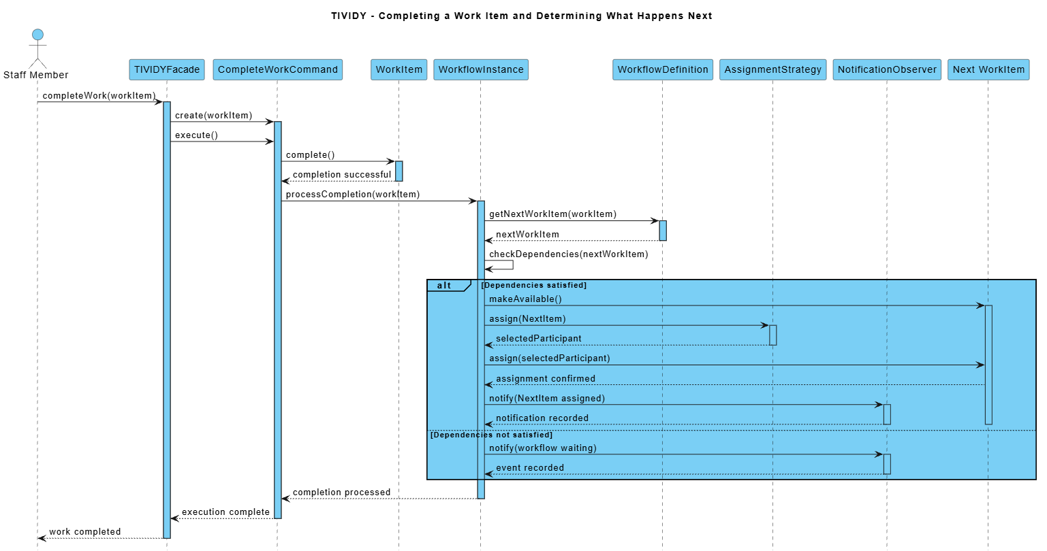
Sequence Diagram: Completing a Work Item and Determining What Happens Next
This sequence diagram illustrates how TIVIDY processes the completion of a WorkItem and determines what happens next in the workflow. A staff member completes the work item through the TIVIDYFacade, which creates and executes a CompleteWorkCommand. The command completes the WorkItem and then notifies the WorkflowInstance that the work item has been completed. The WorkflowInstance consults the WorkflowDefinition to determine the next work item and checks whether its dependencies have been satisfied. If the dependencies are satisfied, the next work item is made available and the AssignmentStrategy selects an appropriate participant. The NotificationObserver is then notified of the assignment. If the dependencies are not satisfied, the workflow remains waiting and the event is recorded. This demonstrates the collaboration between the Command, Strategy, and Observer patterns within TIVIDY's workflow execution process.

Sequence Diagram: Escalating a Complaint
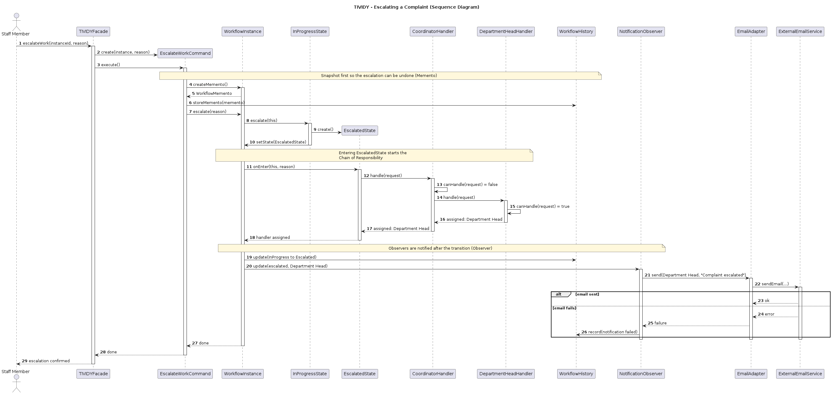
This sequence diagram illustrates how TIVIDY processes the escalation of a complaint that cannot be resolved at the current level. A staff member calls escalateWork() on the TIVIDYFacade, which creates and executes an EscalateWorkCommand. Before anything changes, the command asks the WorkflowInstance for a WorkflowMemento and stores it in the WorkflowHistory so the escalation can be undone. The command then asks the WorkflowInstance to escalate, and the InProgressState replaces itself with an EscalatedState. Entering the EscalatedState starts the escalation chain: the CoordinatorHandler cannot handle the request and passes it on, and the DepartmentHeadHandler accepts it, so the Department Head is assigned. The WorkflowInstance then notifies its observers: the WorkflowHistory records the change from In Progress to Escalated, and the NotificationObserver asks the EmailAdapter to email the Department Head through the ExternalEmailService. If the email fails, the failure is recorded in the history and the escalation still stands. This demonstrates the collaboration between the Facade, Command, Memento, State, Chain of Responsibility, Observer and Adapter patterns within TIVIDY.
State diagram: WorkItem State Lifecycle
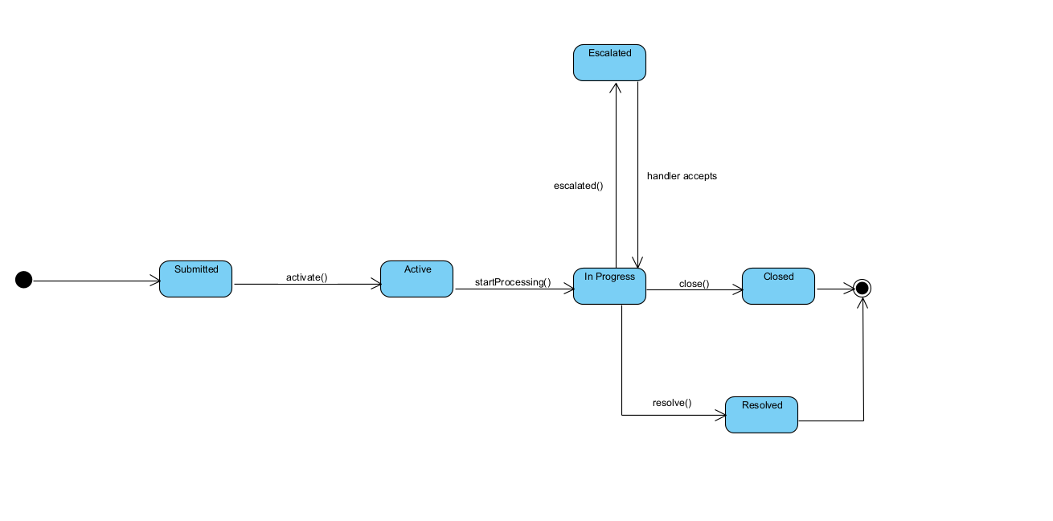
This state diagram illustrates the lifecycle of a TIVIDY WorkflowInstance from submission to completion. A workflow progresses through the states Submitted, Active, and In Progress as the case is processed. If the case cannot be handled at the current level, it enters the Escalated state and returns to In Progress when a handler accepts it. From In Progress, the workflow can either become Resolved when the case is successfully completed or Closed when the workflow ends without resolution. Resolved and Closed represent the final states of the workflow.

